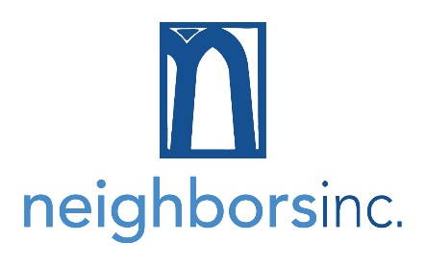
PLANNED GIFT INTENTION FORM
The Legacy Builders Circle recognizes those who make a provision for Neighbors Inc. in their will or estate plans toward helping their neighbors in need.

I/We, ______________________________________________________________ have identified Neighbors, Inc., as an intended beneficiary in my/our estate planning documents.

This gift is identified in my/our:
  - Will dated _________________________
  - Revocable Trust dated________________________
  - As a beneficiary of my qualified plan benefits:
    - IRA
    - 401(k)
    - 403(b)
  - As a beneficiary of an insurance policy on the life of _____________________
  - Other ___________________

I want to support Neighbors, Inc. in its mission to provide opportunities for our neighbors to thrive by connecting volunteers with people in need - today and past my life. Please use this plan and my donation to help feed, clothe, and provide essential services to people in need in northern Dakota County

Please indicate how you prefer to be recognized in Neighbors, Inc. materials. Please list me/us as: _________________________________________________________________________
- or I/we wish to remain anonymous.

Completion of this form is not intended to be legally binding, but notification of intent. Please discuss your planned giving intentions with your professional financial advisor.

Your contributions to Neighbors, Inc. are tax deductible to the full extent of the law.
Please mail or email this form to: Beth Skwira, Director of Development, Neighbors, Inc.
222 Grand Avenue West, South St. Paul, MN 55075
Phone: 651-306-2148
www.neighborsmn.org
Neighbors, Inc. never sells, rents or shares donor information outside the organization. Neighbors, Inc. is a tax-exempt nonprofit organization recognized by section 501(c)(3) of the Internal Revenue Code.
Tax ID #41-1360294.

