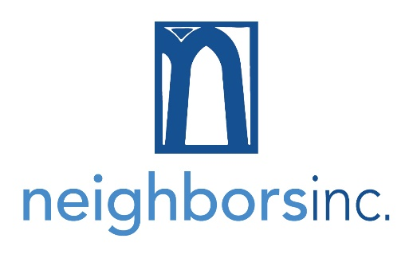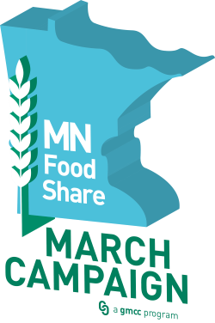
We are grateful for your help as we work to raise a combined total of 350,000 pounds/dollars during this year’s Minnesota FoodShare March Campaign. Church reps like you are key to helping us reach that goal and feed our neighbors in need. Below you will find some background information and ideas to help you make your church’s drive as successful as possible.

If you have any questions or need any additional information, please don’t hesitate to contact Darcy at 651-360-2149 or darcy@neighborsmn.org.

Thank you for your partnership – we could not do this without you!

2020 Minnesota FoodShare March Campaign
- The campaign runs from March 1 – April 12, 2020. (Donations may be received on Monday, April 13 since Neighbors is closed on Sundays.)
- All monetary, food and non-food items donated to the food shelf during the campaign count toward the total.
- Known donations that haven’t yet been received can be counted! Contact Darcy if you have food or funds that are coming but won’t be delivered to the office by April 13.

How You Can Help
- Hang the Neighbors’ posters at your church and throughout the community.
- Ask the church bulletin editor to include FoodShare-related articles throughout the campaign.
- Ask clergy for time during services to share information about the campaign and the impact it has on the community. NOTE: Neighbors has staff and volunteers who are willing to come and speak!
- Share the food shelf needs list with your members.
- Suggest a study group focus on hunger issues.
- Recruit an energetic and motivated leader to organize a food drive or food challenge.
- Provide examples about how much the cost of something like a cup of coffee relates to buying food for a family in need.
- Share statistics about how much the local community uses Neighbors’ programs and services.
- Solicit ideas and input from your congregation!
- Visit www.neighborsmn.org/partner-resources for downloadable resources and information.

See reverse side for bulletin information and statistics.

Church Bulletin / Newsletter Information

Thank you for supporting Neighbors, Inc. during Minnesota FoodShare’s March Campaign. We appreciate your partnership and want to provide you with resources to use during your congregation’s drive. Below you will find templates for bulletin copy – feel free to edit to best fit your needs.

Five reasons to donate to Neighbors this March
For 38 years, the Minnesota FoodShare March Campaign has helped raise food, funds and awareness to help fight hunger across the state. So why is it so important?
- This annual effort helps raise more than half the food distributed by the 300 participating food shelves in the state. Last year, Neighbors received a combined total of 327,441 pounds/dollars – this year, they hope to hit 350,000 to help feed their neighbors in need. This goal is critical in helping keep the shelves stocked in the Neighbors food shelf. In 2019, individuals visiting the food shelf increased by 13%.
- The Neighbors food shelf serves an average of 600 families each month.
- Over 1 million pounds of food was distributed through Neighbors last year.
- Nearly one in eleven Minnesotans experiences food insecurity.
- 100 percent of contributions to the Minnesota FoodShare March Campaign support hunger relief.

Hunger in our community
A few weeks ago, Karen* came to Neighbors who didn’t have an extra dollar to spend on food until the end of the week. She visited Neighbors Express, the new daily food pantry program, every day that week and found something to eat for dinner each day. She was very appreciative for the support during this difficult week. Help a neighbor in need – donate to Neighbors, Inc. this March. More information can be found at www.neighborsmn.org.
INSERT DETAILS SPECIFIC TO YOUR CONGREGATION’S FOOD/FUND DRIVE

Help stock the shelves for your neighbors
Amy* has lived in Minnesota for five years. She and her husband moved here from Florida for a job. She says their first visit was in August and if she had known what Minnesota winters were like, she might not have agreed. Besides the cold temperatures, Amy finds Minnesota to be a welcoming, friendly community and loves the people. She is happy to be here. Sometimes she and her husband struggle financially. She is extremely grateful for the help and support of her new Minnesota community to help them put food on the table. Your food donations help people like Amy and her family get through the challenging times.
INSERT DETAILS SPECIFIC TO YOUR CONGREGATION’S FOOD/FUND DRIVE

Last chance to make your donation go even farther!
This is it – the last week of the Minnesota FoodShare March Campaign! If you’ve still got food or funds to give, please be sure they are in by CHURCH DEADLINE so that we can get a final tally to Neighbors. INSERT DETAILS SPECIFIC TO YOUR CONGREGATION’S FOOD/FUND DRIVE

Thank you for helping your neighbors in need!
Thank you to everyone who participated in our food drive during the Minnesota FoodShare March Campaign. With your generiousity, we INSERT RESULTS.
Interested in other ways you can support Neighbors throughout the year? Visit www.neighborsmn.org to learn more.

*Names and some identifying details have been changed to protect client’s privacy.

